**ORACLE LAB-PRACTICE**

**Sanjay P**

**731621106042**

**KSRIET**

**SALES TABLE CREATION**

**1.Retrieve all columns from the Sales table.**

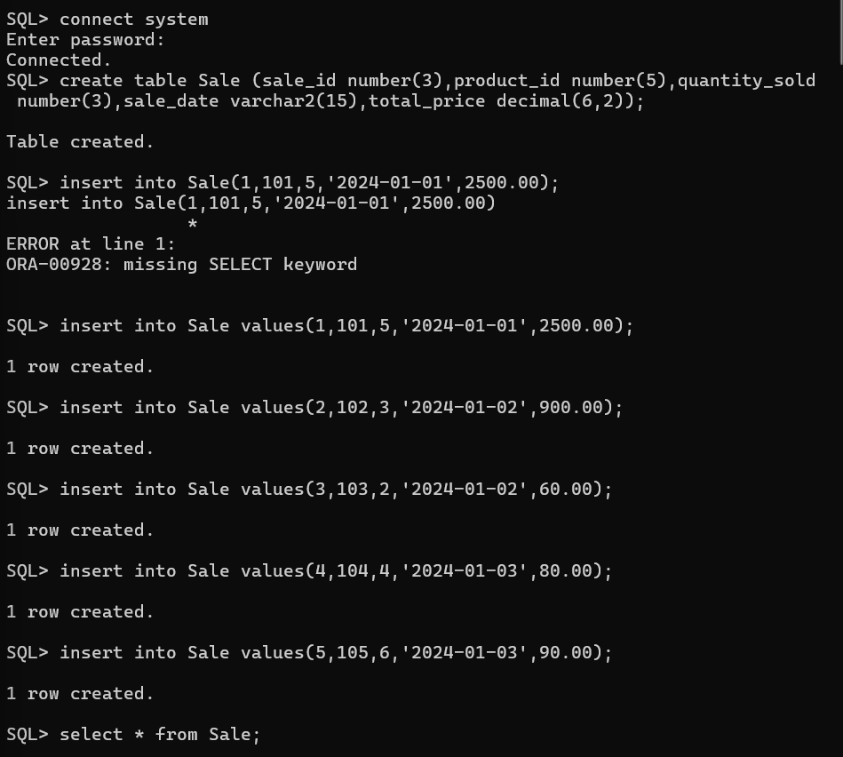

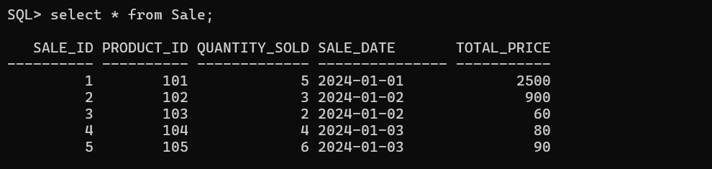

**2. Retrieve sale_id and quantity_sold from sales table.**

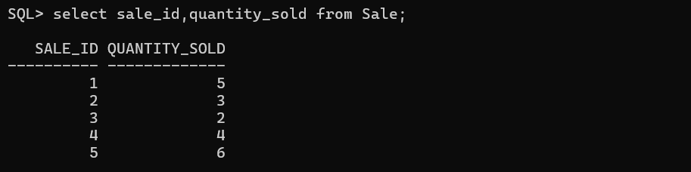

**3. Retrieve the sale_id and sale_date from the Sales table.**

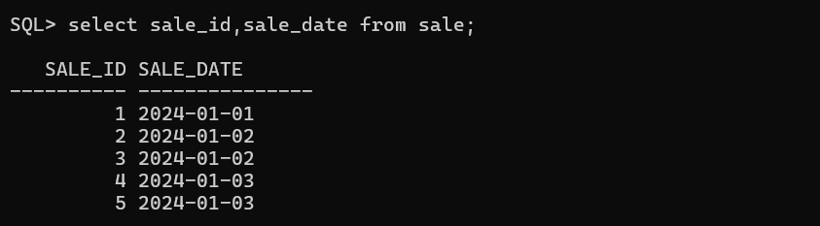

**4. Filter the Sales table to show only sales with a total_price greater than $100.**

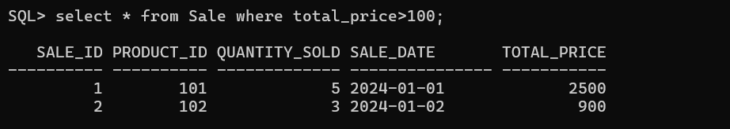

**5. Retrieve the sale_id and total_price from the Sales table for sales made on January 3, 2024.**

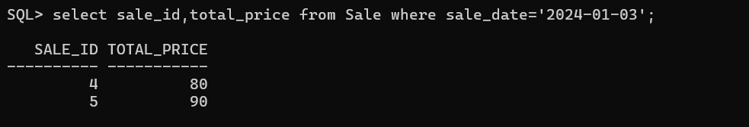

**6. Retrieve the sale_id, product_id, and total_price from the Sales table for sales with a quantity_sold greater than 4.**

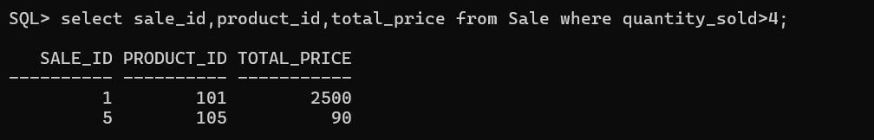

**7. Retrieve all columns from the Sales table those sale_id are 1, 3 & 5.**

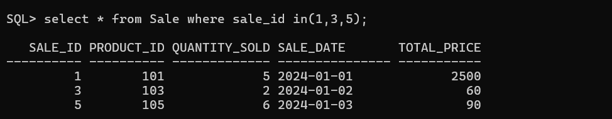

**8. Retrieve all columns from the Sales table those total_price between 90 and 1000.**

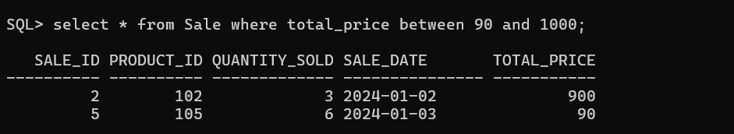

**9. Retrieve all columns from the Sales table those total_price not between 90 and 1000.**

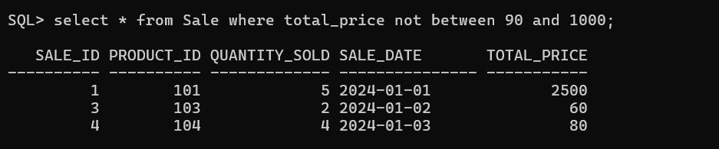

**10. Retrieve all columns from the Sales table those sale_id are not in 1, 3 & 5.**

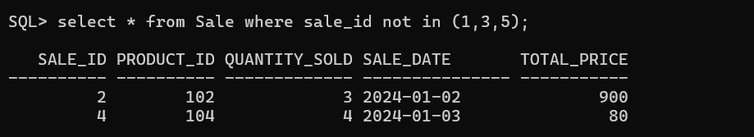

**11.  Update total_price as 500 in  the Sales table those sale_id are 1, 3 & 5.**

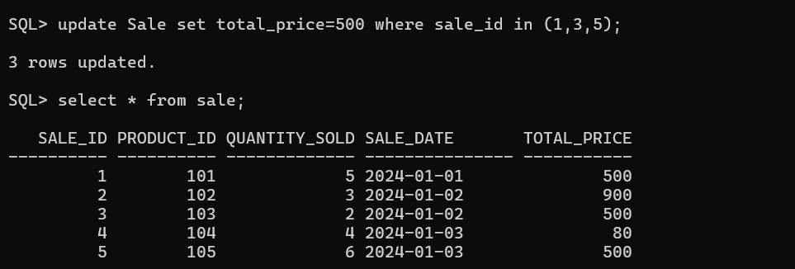

**12. delete from the Sales table those total_price not between 90 and 1000.**

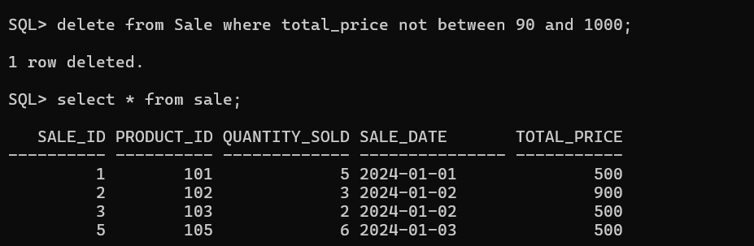

**13. Sort all the records using sale_id column in ascending order.**

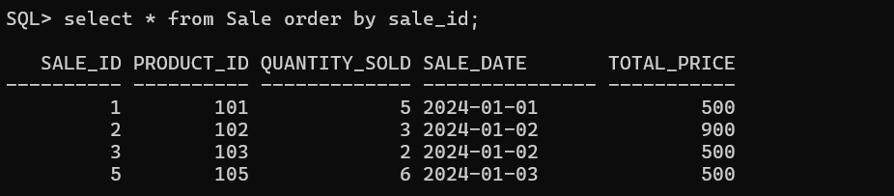

**14. Sort all the records using sale_id column in descending order.**

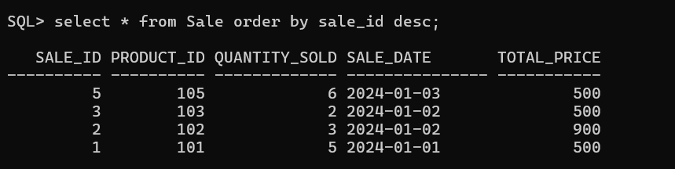

**15. Rename the sale_id column as sales_id;**

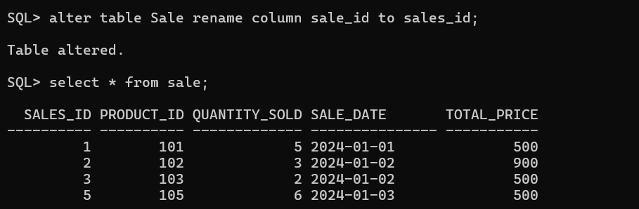

**16. Drop the column sales_id.**

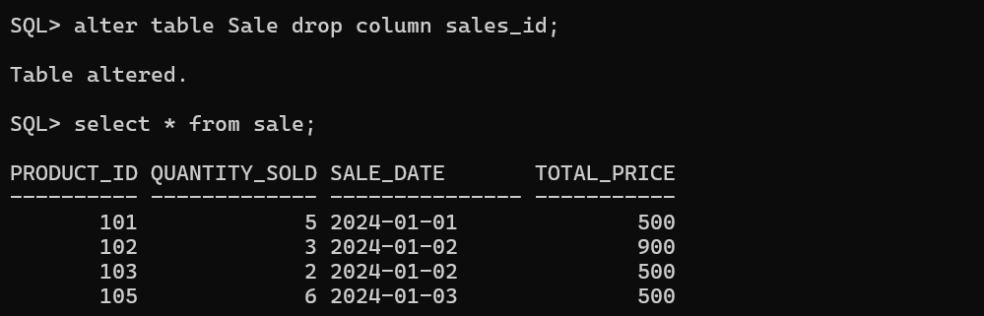

**17. Rename the table as tbl_sales.**

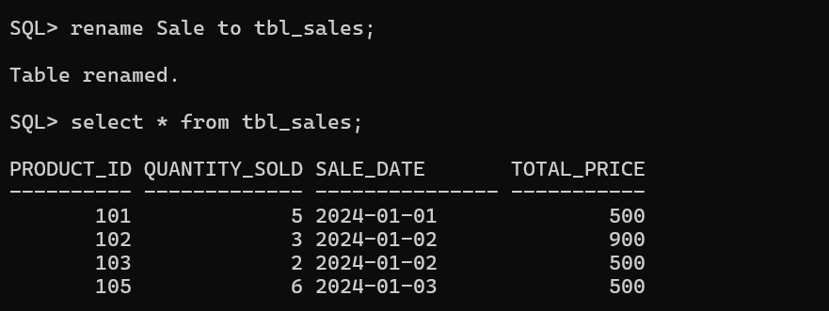

**18. Drop the table.**

